Compensation and Pension Records Interchange (CAPRI) Deployment, Installation, Back-Out, and Rollback Guide



March 2019

Department of Veterans Affairs

Office of Information and Technology (OI&T)

Revision History

|  |  |  |  |
| --- | --- | --- | --- |
| Date | Version | Description | Author |
| 04/03/2019 | 0.07 | Updates per HPS review:   * Section 1.2 Dependencies, Corrected Required Builds List, and removed reference from 4th bullet. * Section 3.0 Deployment, Corrected National Release dates, revised 24-day compliance to 30-day, revised DVBA*2.7*192 to DVBA*2.7*193, removed 24-day release schedule numbered list of special instructions. * Section 3.2.2 Site Information, corrected Test Sites. * Section 3.2.3 Site Preparation, removed information and entered N/A under the Actions/Steps cell in 1st row of Table 4. * Section 3.2.6 Communication, list number 4., removed Note from end of paragraph. * Section 4.1 Pre-Installation and System Requirements, remove 1st paragraph. * Section 4.2 Platform Installation and Preparation, removed 1st sentence from 1st paragraph. * Section 4.3 Download and Extract Files, under “Optional Distribution Files….”, corrected file names to match the naming conventions for files in Rational. * Section 4.4 Database Creation, remove paragraph, enter N/A. * Section 4.7.7 CAPRITerminalEmulators.ini, remove 2nd sentence from 1st bulleted paragraph. | C. Bernier |
| 03/13/2019 | 0.06 | Updated dates for IOC, national deployment and warrenty. Updated GUI release package zip contents | C. Rolle |
| 02/27/2019 | 0.05 | Updated references to P193 with P209 where necessary.  Updated month date on title page and in footers to March 2019. | C. Bernier |
| 08/14/2018 | 0.04 | Updated month date on title page and in footers to September 2018. | C. Bernier |
| 08/13/2018 | 0.03 | Section 3. Deployment:   * Per review comments, revised this entire section: text, release dates, and compliance period to 24-days. * Section 3.1 Timeline: Per review comments, revised warranty period to 90 days and updated National Implementation finish date to 10/11/2018.   Global: Updated Headings to make consistent throughout the document. | C Bernier |
| 08/07/2018 | 0.02 | Section 3. Deployment:   * Changed 193.11 references in 1st two NOTES to 193.12 * #1 under 30 day release schedule, changed 193.11 reference to 193.12   Section 3.1 Timeline, in table, updated Start/Finish dates for IOC Testing, National Implementation, and Warranty Period.  Section 4. Installation, changed 193.11 reference in NOTE to 193.12.  Section 4.7 CAPRI GUI Installation Procedures, changed 193.11 reference in NOTE to 193.12. | C. Bernier |
| 05/15/2018 | 0.01 | Initial Document developed for Patch DVBA *2.7*193.11 | C. Bernier |

**Artifact Rationale**

This document describes the Deployment, Installation, Back-out, and Rollback Plan for new products going into the VA Enterprise. The plan includes information about system support, issue tracking, escalation processes, and roles and responsibilities involved in all those activities. Its purpose is to provide clients, stakeholders, and support personnel with a smooth transition to the new product or software, and should be structured appropriately, to reflect particulars of these procedures at a single or at multiple locations.

Per the Veteran-focused Integrated Process (VIP) Guide, the Deployment, Installation, Back-out, and Rollback Plan is required to be completed prior to Critical Decision Point #2 (CD #2), with the expectation that it will be updated throughout the lifecycle of the project for each build, as needed.

Table of Contents

1. Introduction 5

1.1. Purpose 5

1.2. Dependencies 5

1.3. Constraints 5

2. Roles and Responsibilities 6

3. Deployment 6

3.1. Timeline 7

3.2. Site Readiness Assessment 7

3.2.1 Deployment Topology (Targeted Architecture) 7

3.2.2 Site Information (Locations, Deployment Recipients) 8

3.3.3 Site Preparation 9

3.2.4 Hardware 9

3.2.5 Software 9

3.2.6 Communications 9

4. Installation 10

4.1. Pre-installation and System Requirements 10

4.2. Platform Installation and Preparation 11

4.3. Download and Extract Files 11

4.4. Database Creation 13

4.5. Installation Scripts 13

4.6. Access Requirements and Skills Needed for the Installation 13

4.7. Additional Installation Files 13

4.7.1 VACAPRIVVA.dll 13

4.7.2 LIBEAY32.DLL & SSLEAY32.DLL 14

4.7.3 QPDF.EXE, QPDF13.DLL, LIBGCC_S_DW2-1.DLL & LIBSTDC++-6.DLL 14

4.7.4 CAPRI_Help.chm 14

4.7.5 CAPRI.map 14

4.7.6 CAPRISession.rdox 15

4.7.7 CAPRITerminalEmulators.ini 15

4.7.8 ssh_config 15

4.8 CAPRI Configuration for Windows 7 and Non-standard Reflection Installations 16

Windows 7 Installation 16

Non-standard Reflection Installations 17

4.9 New Micro Focus Reflections Release 18

4.10 Windows 7 Font Size on Certain Screens 19

4.10.1 Steps to correct Font size on certain screens in Windows 7 19

4.10.2 Microsoft Office Imaging on Windows 7 Workstations 20

4.10.3 Shared Network Drive or CAPRI access via CPRS Installations 21

4.10.4 CAPRI Graphical User Interface (GUI) Verification Procedure 23

4.11 Back-Out 25

4.12 Rollback Procedure 25

4.13 Rollback Considerations 25

4.14 Rollback Criteria 25

4.15 Rollback Risks 25

4.16 Authority for Rollback 26

# Introduction

This document describes how to deploy and install the Compensation and Pension Record Interchange (CAPRI), as well as how to back-out the product and rollback to a previous version or data set. This will include installation of CAPRI Patch DVBA*2.7*209 and a corresponding client (GUI) application. This document is a companion to the project charter and management plan for this effort. In cases where a non-developed COTS product is being installed, the vendor provided User and Installation Guide may be used, but the Back-Out Recovery strategy still needs to be included in this document.

## Purpose

The purpose of this plan is to provide a single, common document that describes how, when, where, and to whom CAPRI will be deployed and installed, as well as how it is to be backed out and rolled back, if necessary. The plan also identifies resources, communications plan, and rollout schedule. Specific instructions for installation, back-out, and rollback are included in this document.

## Dependencies

CAPRI is a system that gives Veterans Benefits Administration (VBA) claims processors and others access to compensation and pension examinations, clinical documents, and reports vital to process benefits claims. CAPRI consists of VistA patch DVBA*2.7*209 and a client application (GUI). Installation requires the following prerequisites:

* VistA Patches (for VHA only)

The following is a list of REQUIRED builds for this KIDS distribution (DVBA*2.7*209). KIDS will not allow the installation of this patch without their prior installation.

**Required Builds**:

DVBA*2.7*193

* Approved release from the VIP Triad.
* Test site sign-off from VBA Beta Sites and VHA IOC Sites.
* VIP Release Review Approval for Patch DVBA*2.7*209 Critical Decision 2 (CD2).

## Constraints

The VistA component of CAPRI will be installed into all instances of VistA. The client (GUI) will be installed on the Windows-based workstations of CAPRI’s users according to local policies and procedures. Since the VistA component will make changes to the 2507 Requests File (#396.3) in VistA and since the existing client (GUI) is incompatible with those changes, the new client (GUI) must roll out to VBA first to ensure backwards-compatibility with the old database format and to minimize disruption to VBA’s business processes.

There are no identified constraints to the installation of this VistA component of CAPRI.

# Roles and Responsibilities

This section describes the teams who perform the steps described in this deployment plan.

Deployment and installation activities are performed by representatives from the teams listed in the following table. This phase begins after the solution design (including deployment topology) is complete. Design activities are not included in this phase.

| **Team** | **Phase / Role** | **Tasks** | **Project Phase (See Schedule)** |
| --- | --- | --- | --- |
| CAPRI Development Team | Deployment | Plan and schedule deployment | Deployment |
| CAPRI Development Team | Deployment | Develop O&M Plan | Deployment |
| Release Readiness | Testing | Conduct VIP Release Review Approval | Testing |
| Test Sites | Testing | IOC and BETA Tests Patch DVBA*2.7*209 | Testing |
| VBA/VHA Business Offices | Deployment | Develop Communications Plan and key messages well in advance | Deployment |
| Health Product Support | Testing | Review Patch DVBA*2.7*209 | Testing |
| Health Product Support | Deployment | Release Patch DVBA*2.7*209 nationally | Deployment |
| Regional PM/FIS/OPP PM | Installation | Ensure authority to operate and that certification and authorization (C&A)/security documentation is in place | Installation |
| Infrastructure Operations | Installation | Install the patch as scheduled | Installation |

Table 1 Deployment Roles and Responsibilities

# Deployment

Deployment and installation of the Compensation and Pension Record Interchange (CAPRI) is planned as follows:

1. **National Release: 04/12/19 – 05/13/19** CAPRI GUI v2.7 209 will be deployed to all CAPRI Users, and corresponding VistA Patch DVBA*2.7*209 will be deployed to all 130 instances of VistA within a 30-day compliance period.

**NOTE:** CAPRI GUI V2.7 209.01 requires a Version Control check against VistA patch DVBA*2.7*209 Version Control file that will ensure that all VA Sites and CAPRI Users will be operating under CAPRI GUI v2.7 209 after DVBA*2.7*209 has been installed.

**NOTE:** CAPRI GUI v2.7. 209 is backward compatible with VistA patch DVBA*2.7*193 It is recommended that CAPRI GUI v2.7. 209 be deployed to as many users as possible prior to installing VistA Patch DVBA*2.7*209 in order to minimize and avoid disruptions of service to the CAPRI National or Remote Users.

The release of the patch will be performed by Health Product Support (HPS) members, supported by the CAPRI project team, along with representatives from peer organizations. The installation will be performed by Local, VISN, or Regional IT support personnel.

## Timeline

The installation and deployment runs for 90 days, which includes a warranty period to monitor for defects. The approximate timeline for this effort is shown in the table below:

| **Phase** | **Activity** | **Start** | **Finish** |
| --- | --- | --- | --- |
| General Release | IOC Testing | 03/19/2019 | 04/1/2019 |
| National Implementation | 04/12/2019 | 05/13/2019 |
| Warranty Period | 04/12/2019 | 07/11/2019 |
| (Dates shown are subject to change due to unforeseen circumstances.) | | | |

Table 2 CAPRI Patch DVBA*2.7*209 Deployment Timeline

## Site Readiness Assessment

This deployment will enhance the capabilities of the existing CAPRI system. This section discusses the locations that will receive the upgrades to the CAPRI system.

### 3.2.1 Deployment Topology (Targeted Architecture)

Implementation of CAPRI Patch DVBA*2.7*209 has two components:

1. The client (GUI) application needs to be installed onto all user workstations so that VBA and VHA users may access the client from their government computer workstations.
2. The VistA component of the new version needs to be installed into all instances of VistA. All facilities will use their established local procedures to install the new software.

Additionally, a nationally released patch updates the files in VistA and only affects the Users with the appropriate CAPRI menu options in VistA.

### 3.2.2 Site Information (Locations, Deployment Recipients)

The new version of CAPRI’s VistA patch (DVBA*2.7*209) will be installed across the entire VA Enterprise for all CAPRI Users to all instances of VistA. The GUI component will install on all user workstations. All facilities in Regions 1-5 will use established location procedures to install the new software.

The following test sites are participating in the testing of the CAPRI GUI v209 and DVBA*2.7*209 server software:

* Test Sites:

|  |  |
| --- | --- |
| **Type** | **Site** |
| **VHA** | **Greater Los Angeles VAMC**  **Minneapolis VAMC**  **Tampa VAMC** |
| **VBA** | **St. Petersburg**  **San Diego**  **WACO** |

Table 3 Test Sites

**NOTE**: The test sites used may change based on a site’s willingness to participate, workload, and other factors. Sites listed in **boldface type** are expected to be primary (“Alpha”) testers. Other sites listed are secondary (“Beta”) testers who will help us uncover any hidden defects before we release nationally.

### 3.3.3 Site Preparation

The following table describes preparation required by the site prior to deployment.

| **Site/Other** | **Problem/Change Needed** | **Features to Adapt/Modify to New Product** | **Actions/Steps** | **Owner** |
| --- | --- | --- | --- | --- |
| All | Create backups | N/A | N/A | Local facility, VISN, or Region |
| All | Install new software (GUI) | Installation script(s) | If applicable, each facility should create scripts to remove the old client (GUI) software and to install the new version on their user workstations. | Local facility, VISN, or Region |

Table 4 Site Preparation Resources

This section describes the resources needed for deployment and installation.

### 3.2.4 Hardware

There are no new hardware requirements for this software update.

### 3.2.5 Software

The following list describes software specifications required at each site prior to deployment. The corresponding GUI requires a Windows-based workstation for each user.

Associated patches that must be installed BEFORE `DVBA*2.7*209

CAPRI DVBA*2.7*193

Table 5 Software Specifications

Please see the Roles and Responsibilities table in Section 2 above for details about who is responsible for preparing the site to meet these software specifications.

### 3.2.6 Communications

This section describes the communications that need to occur to upgrade CAPRI:

1. The CAPRI Development Team will provide the GUI associated with Patch DVBA*2.7*209 to VBA Region 5, who in turn will follow their procedures to notify users and to install the new GUI on all user workstations in the Region.
2. The CAPRI Development Team will provide the GUI associated with Patch DVBA*2.7*209 to National CAPRI Users with critical business needs (such as the Veterans Crisis Line and Health Resource Center), who in turn will follow their procedures to notify users and to install the new GUI on all user workstations in the Region.
3. The CAPRI Development Team will provide the installation files to VHA and other users (see Section 4). We will work with VHA to proactively notify users to the maximum extent possible, but it is recognized and understood that we may not reach everyone prior to installation of the VistA patch.
4. We will work with representatives from Health Information Access (HIA) to notify all National CAPRI Users about the need to upgrade the GUI. However, many of these users do not fall under a single administrative umbrella. It is therefore recognized and understood that we may not reach everyone.
5. The CAPRI Deployment Team will conduct weekly status conference calls and ad-hoc calls with test sites and stakeholders to provide status and answer questions.

# Installation

This section describes how to install CAPRI.

**NOTE:** CAPRI GUI V2.7 209.01 requires a Version Control check against VistA patch DVBA*2.7*209 Version Control file that will ensure that all VA Sites and CAPRI Users will be operating under CAPRI GUI v2.7 209 after DVBA*2.7*209 has been installed.

## Pre-installation and System Requirements

The installation of the patch will be introducing new files, updating routines, parameters, remote procedure calls, and options.

1. Choose the PackMan message containing this patch.
2. Choose the INSTALL/CHECK MESSAGE PackMan option.
3. From the Kernel Installation and Distribution System Menu, select the Installation Menu. From this menu, you may elect to use the following options. When prompted for the INSTALL NAME enter the patch DVBA*2.7*209:
4. Backup a Transport Global - This option will create a backup message of any routines exported with this patch. It will not backup any other changes such as DDs or templates.
5. Compare Transport Global to Current System - This option will (allows you to view all changes that will be made when this patch is installed. It compares all components of this patches routines, DDs, and templates).
6. Verify Checksums in Transport Global - This option will allow you to ensure the integrity of the routines that are in the transport global.
7. From the Installation Menu, select the Install Package(s) option and choose the patch to install.
8. When prompted ‘Want KIDS to Rebuild Menu Trees Upon Completion of Install? Select NO
9. When prompted ‘Want KIDS to INHIBIT LOGONs during the install? Select NO
10. When prompted 'Want to DISABLE Scheduled Options, Menu Options, and Protocols? Select NO
11. If prompted ‘Delay Install (Minutes): (0 – 60): 0//’ respond 0.
12. If CAPRI GUI users have not already been upgraded to the new version of the CAPRI GUI v209 (CAPRI.exe [DVBA_27_209.ZIP]), they should be upgraded as soon as possible upon installation of this patch.

## Platform Installation and Preparation

In order to maintain continuity of business operations for VBA and for business-critical National CAPRI Users while at the same time validating the new functionality of DVBA*2.7*209 and its corresponding GUI in a limited production environment, VBA and National CAPRI Users were provided a version of the GUI that maintained backwards-compatibility with the old format. Consequently, we do not anticipate difficulties with version incompatibility. Nevertheless, we recommend deploying the new GUI **before** installing VistA patch VBA*2.7*209 into all 130 VistA production systems.

All sites should make sure that their test environments mirror the state of their production environments. This is important because it helps identify deficiencies (such as outdated or missing patches) when the new software is installed into the test environment rather than into the production environment.

## Download and Extract Files

All files needed to install CAPRI Patch DVBA*2.7*209 can be downloaded from the standard “anonymous” software directory.

The CAPRI GUI client software and documentation are available using FTP. The preferred method is to FTP the files from:

ftp://download.vista.med.va.gov/

(Files will be in an anonymous.software directory)

This transmits the files from the first available FTP server. Sites may also elect to retrieve software directly from a specific server as follows:

| **OIT FIELD OFFICE** | **FTP ADDRESS** | **DIRECTORY** |
| --- | --- | --- |
| Hines | ftp.fo-hines.med.va.gov | [anonymous.software] |
| Salt Lake City | ftp.fo-hines.med.va.gov | [anonymous.software] |

The following files will be available:

Required Distribution Files to Run the CAPRI Application

File Name Contents Retrieval format

--------- -------- ---------------

DVBA_27_P209_01.ZIP File(s) indented below: BINARY

|  |  |
| --- | --- |
| capri.exe | CAPRI V209 executable |
| capri.map | CAPRI error map |
| CAPRI_DVBA_27_209_ISG.docx | Installation Guide |
| CAPRI_Help.chm | Help link |
| CAPRISession.rdox | Reflections session configuration |
| CapriTerminalEmulators.ini | Terminal Emulator |
| libeay32.dll | VLER/DAS SSL dynamically linked library |
| libgcc_s_dw2-1.dll | QPDF dynamically linked library |
| libstdc++-6.dll | QPDF dynamically linked library |
| qpdf.exe | QPDF PDF Compression executable |
| qpdf13.dll | QPDF dynamically linked library |
| ssh_config | Secure Shell configuration |
| ssleay32.dll | VLER/DAS SSL dynamically linked library |
| VACAPRIVVA.dll | Virtual VA dynamically linked library |

Optional Distribution Files which Contain Important User Info

DVBA_27_209_ISG.pdf GUI Installation Supplemental Guide

DVBA_27_209_RN.pdf Patch Release Notes BINARY

DVBA_27_209_UM.pdf Updated CAPRI User Manual BINARY

DVBA_27_209_Sys_Adm.pdf SAT GUIDE BINARY

|  |  |
| --- | --- |
| **File Name** | **Description** |
| DVBA_27_P209.KID | KIDS file: DVBA*2.7*209  (Delivered via Forum) |
| DVBA_27_P209_01.ZIP | GUI Install Archive (compressed archive containing executables, where *nn* is the final version number) |

Table 6 Files to Download

## Database Creation

N/A

## Installation Scripts

All sites will follow their local procedures to install the software in accordance with the Installation Guide.

## Access Requirements and Skills Needed for the Installation

Installation of VistA Patch DVBA*2.7*209 requires VistA programmer access.

Installation of the GUI requires administrator rights on the user workstation.

**NOTE:** CAPRI GUI V2.7 209 requires a Version Control check against VistA patch DVBA*2.7*209 Version Control file that will ensure that all VA Sites and CAPRI Users will be operating under CAPRI GUI v2.7 209 after DVBA*2.7*209 has been installed.

## Additional Installation Files

In addition to the executable file, there are other files included with the CAPRI installation zip. The general purpose of these files and where they need to be located are as follows:

### 4.7.1 VACAPRIVVA.dll

The VACAPRIVVA.dll file is a dynamic link library that provides the web services client interface for the Virtual VA web service, which was added in patch DVBA*2.7*181. **Important: CAPRI will not function without this file.**

* VACAPRIVVA.dll is required for CAPRI to function.
* VACAPRIVVA.dll must be located in the same directory as the CAPRI executable (CAPRI.exe).

The following dialog box displays when CAPRI cannot find the VACAPRIVVA.dll file.

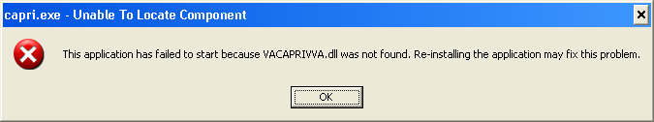

Figure 1. Missing File Alert

### 4.7.2 LIBEAY32.DLL & SSLEAY32.DLL

Libeay32.dll and Ssleay32.dll are dynamic link libraries that provide the web services client interface for the VLER/DAS web service, which was added in patch DVBA*2.7*187. **Important: CAPRI requires these files to transfer exam data to VLER/DAS.**

* Libeay32.dll and Ssleay32.dll are required for exam data transfer to VLER/DAS.
* Libeay32.dll and Ssleay32.dll must be located in the same directory as the CAPRI executable (CAPRI.exe).

### 4.7.3 QPDF.EXE, QPDF13.DLL, LIBGCC_S_DW2-1.DLL & LIBSTDC++-6.DLL

QPDF.exe, QPDF13.DLL, LIBGCC_S_DW2-1.DLL & LIBSTDC++-6.DLL are files that support PDF Compression and Linearization. PDF Compression reduces the file size of the PDF Exam Results included in transmissions between CAPRI and VLER/DAS. Smaller file sizes reduce transmission times.

* QPDF.exe, QPDF13.dll, Libgcc_s_dw2-1.dll and Libstdc++-6.dll are required for PDF compression when sending exam data to VLER/DAS.
* QPDF.exe, QPDF13.dll, Libgcc_s_dw2-1.dll and Libstdc++-6.dll must be located in the same directory as the CAPRI executable (CAPRI.exe).

### 4.7.4 CAPRI_Help.chm

The CAPRI_Help.chm file contains the on-line help functionality.

CAPRI_Help.chm is not required for CAPRI to function, but its presence is recommended

CAPRI_Help.chm should be located in the same directory as the CAPRI executable (CAPRI.exe)

If CAPRI is setup to run from a disk drive that is not local to the workstation, CAPRI should be given write permissions to the “TEMP” folder of the workstation. If the TEMP folder is not writable for any reason, the on-line help functionality may not work properly.

### 4.7.5 CAPRI.map

The CAPRI.map file contains a list of error addresses and source code line numbers that CAPRI utilizes to provide more detailed information to the development team when an error occurs in CAPRI.

CAPRI.map is not required for CAPRI to function, but its presence is recommended

CAPRI.map should be located in the same directory as the CAPRI executable (CAPRI.exe)

### 4.7.6 CAPRISession.rdox

* CAPRISession.rdox is a Micro Focus Reflection configuration file. It configures Reflection to terminate when a terminal session disconnects.
* CAPRISession.rdox is used for the new Micro Focus Reflection application
* CAPRISession.rdox is not required for CAPRI to function, but its presence is recommended
* CAPRISession.rdox should be located in the same directory as the CAPRI executable (CAPRI.exe)

### 4.7.7 CAPRITerminalEmulators.ini

* CAPRITerminalEmulators.ini is a Micro Focus Reflection configuration file. It tells CAPRI where the Micro Focus Reflections application is installed.
* CAPRITerminalEmulators.ini should be located in the same directory as the CAPRI executable (CAPRI.exe)

### 4.7.8 ssh_config

The ssh_config file provides the parameters used by Micro Focus Reflection Secure Shell to configure PC-to-host security options. CAPRI does not require this file for most functions, but it is required when establishing Reflection Secure Shell terminal sessions using the “Vista” button.

The directory location of the ssh_config file:

C:\Program Files (x86)\Micro-Focus\Reflection

**NOTE:** The target folder for ssh_config is typically hidden on most systems.

To show hidden files and folders on Windows 7, perform the following steps:

1. Click the Start button
2. Click Control Panel
3. Click Appearance and Personalization
4. Click Folder Options
5. In the Folder Options dialog, select the “View” tab
6. Select “Show hidden files and folders,” and then click OK

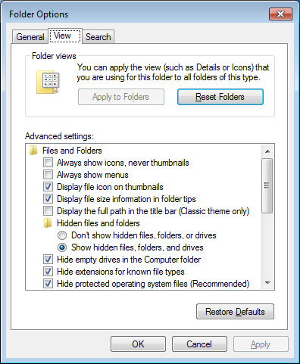

Figure 2. Show Hidden Files

## 4.8 CAPRI Configuration for Windows 7 and Non-standard Reflection Installations

Prior to launching Reflection, CAPRI searches the directory path that contains the CAPRI executable (CAPRI.exe) for an optional plain text configuration file named "CapriTerminalEmulators.ini.” The purpose of the configuration file is to specify an alternate path that contains the Micro-Focus Reflection executable (Attachmate.Emulation.Frame.exe). If CAPRI does not detect the configuration file, CAPRI assumes that the Reflection executable exists in the default Windows XP Reflection installation path: "C:\Program Files (x86)\Micro-Focus\Reflection."

### Windows 7 Installation

**NOTE:** Sites that run a mixture of Windows XP and Windows 7 workstations and access the CAPRI executable from a central location, such as a share drive or terminal server, must create a new directory on the share to contain the CAPRI executable and the configuration file. Windows 7 users should access the CAPRI executable from the new directory, while Windows XP users should continue to access the CAPRI executable from the original directory.

The example "CapriTerminalEmulators.ini" configuration file provided with patch DVBA*2.7*180 is configured to provide support for the default installation path of Micro Focus Reflection on a Windows 7 workstation. Place the configuration file in the same directory that contains the CAPRI executable.

Alternatively, use the following procedure to create the configuration file:

Create the configuration file named "CapriTerminalEmulators.ini" using a plain text editor, such as Notepad. Populate the configuration file with the following three lines:

[Config]

ApplicationLegacy=C:\Program Files (x86)\Attachmate\Reflection\R2win.exe

Application="C:\Program Files (x86)\Micro Focus\Reflection\Attachmate.Emulation.Frame.exe"

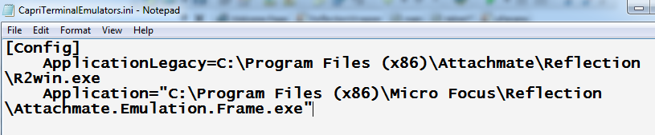

Figure 3. Config File for Standard Reflection Installation

**NOTE:** Save the file and place it in the same directory that contains the CAPRI executable.

### Non-standard Reflection Installations

If Reflection is installed in an alternate location, CAPRI can be configured to accommodate this. In order to do this, one should create a file named "CapriTerminalEmulators.ini" in the directory that contains the "CAPRI.exe" file. In this file, one should specify the location of the "Attachment.Emulation.Frame.exe.” For example, in order to specify a Reflection installation located in "C:\My Files\Attachmate\Reflection,” the CAPRITerminalEmulator.ini should contain the following lines:

[Config]

ApplicationLegacy=C:\My Files\Attachmate\Reflection\R2win.exe

Application="C:\My Files\Attachmate\Reflection\Attachmate.Emulation.Frame.exe"

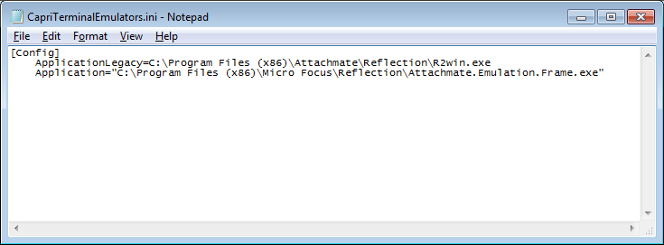

Figure 4. Config File for Non-Standard Reflection Installation

## 4.9 New Micro Focus Reflections Release

A new version of Micro Focus Reflection will be released around the time of this CAPRI release. This Reflection application requires a different configuration file from the previous version. CAPRISession.r2w will be no longer be used but is still included until the upgrade takes place. CAPRISession.rdox is the new configuration file for the new Reflection application. This file is also included. In addition, the CapriTerminalEmulators.ini file has been updated and included in this release.

**NOTE:** If your site uses a non-standard Reflection installation, the CAPRITerminalEmulators.ini file will need to be updated.

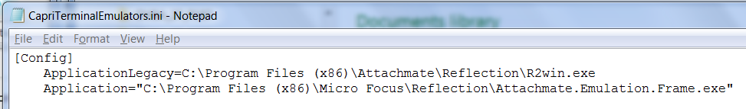

Figure 5. New CapriTerminalEmulators.ini file format

[Config]

ApplicationLegacy=C:\Program Files (x86)\Attachmate\Reflection\R2win.exe

Application="C:\Program Files (x86)\Micro Focus\Reflection\Attachmate.Emulation.Frame.exe"

If your site has a non-standard Reflection location, the ApplicationLegacy line will need to be updated to reflect the value currently used at your site. In the example below***, C:\My Files\Attachmate\Reflection*** was the non-standard site. That value will need to be updated on the ApplicationLegacy line – shown below.

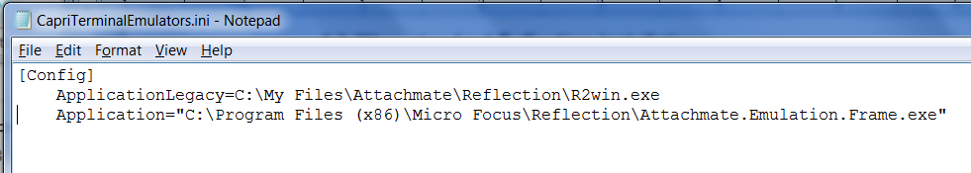

Figure 6. New CapriTerminalEmulators.ini with existing non-standard Reflection location

[Config]

ApplicationLegacy=C:\My Files\Attachmate\Reflection\R2win.exe

Application="C:\Program Files (x86)\Micro Focus\Reflection\Attachmate.Emulation.Frame.exe"

## 4.10 Windows 7 Font Size on Certain Screens

During the Windows 7 install process, under certain hardware and software conditions, the Windows installer may setup the default system fonts larger than the standard fonts used in prior versions of Windows. This can cause screens to display distorted in many applications. This problem affects some CAPRI screens, such as the Enterprise Search dialog.

This display distortion is being reported in many COTS applications, e.g. Microsoft Dynamics and is not specific to CAPRI.

If your workstation is affected, and if you have administrative rights to the workstation, you can follow the steps below to correct the issue.

If you do not have administrative rights to your workstations, you may have to contact your System Administrator for assistance and do not proceed.

### 4.10.1 Steps to correct Font size on certain screens in Windows 7

**NOTE:** Before doing the steps below, make sure that you have a good backup of the Windows Registry.

1. Go to the Start menu click **Run**…
2. Type “**regedit**” and then click **OK**

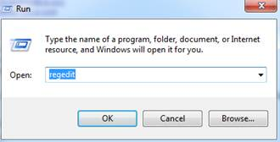

Figure 7. Registry Edit Dialog Window

1. In the Registry Editor, click on the path: HKEY_LOCAL_MACHINE\SOFTWARE\Microsoft\Windows NT\CurrentVersion\Fonts
2. Click **MS Sans Serif 8,10,12,14,18,24**. Right-click and select Modify **SSERIFF.FON** to **SSERIFE.FON** . ***Note:*** *One character of the file name changes from F to E*
3. Click MS Serif 8,10,12,14,18,24. Right-click and select Modify SERIFF.FON to SERIFE.FON . ***Note:*** *One character of the file name changes from F to E*
4. Click **Courier 10,12,15**. Right click and select Modify **COURF.FON** to **COURE.FON** . ***Note:*** *One character of the file name changes from F to E*

**NOTE**: The above changes take effect after system reboot.

### 4.10.2 Microsoft Office Imaging on Windows 7 Workstations

This section outlines information on Installation of Microsoft Office Imaging 2007 (MODI) on Windows 7 workstations to view .TIFF files Steps to correct Font size on certain screens in Windows 7.

**\*\*\*IMPORTANT NOTE\*\*\***

With the introduction of “Get Docs from Virtual VA” in patch DVBA*2.7*184, there was an issue discovered with opening large TIFF files with the current Windows Photo Viewer, which is the default viewer on Windows 7 workstations for TIFF files. For this reason, it is imperative that prior to the installation of CAPRI Patch DVBA*2.7*184 from a network share drive, the system administrators (IRM Staff) *MUST* validate that workstations running on Windows 7 have Microsoft Office Document Imaging 2007 (MODI) installed prior to installing P184 from a network share drive. This notice does not impact workstations running on Windows XP.

If you are upgrading CAPRI in the workstation’s local hard drive, this pre-requisite should already have been met by an Action Item initiated by ESE. Reference national change order CO161098FY13.

However, if one or more of your workstations have windows 7 and these do not have a CAPRI.EXE on local hard disk, i.e. in case of new installs or running CAPRI from a Network Share, on those workstations this pre-requisite has *not* been automatically met. You can meet this pre-requisite by following the instructions on this link

[Microsoft Office (2007) Document Imaging Build Document](http://go.va.gov/3wao)

In this document you may use either the SCCM method or the manual method.

All workstations that will run CAPRI.EXE, MUST have this MODI package installed in order to view large .TIFF files. Even if running CAPRI from the network, this package MUST still be installed on the workstation.

### 4.10.3 Shared Network Drive or CAPRI access via CPRS Installations

If your site installs CAPRI on a Shared Network Drive and users access a “shortcut” to launch CAPRI or if your users access CAPRI via CPRS, the following MUST be performed to allow users to view PDF files from DAS. Users will receive the following error if this is not done.

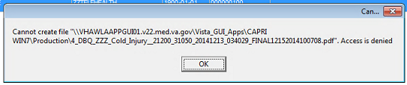

**Figure 8. CAPRI Shortcut Launch Error**

If the “Start In” folder for CAPRI shortcut at your site is a read-only only folder, it should be changed to a writable folder. This is the folder where documents from VLER DAS are stored temporarily for users to view documents (ex: PDF).

Our recommendation is to use %TEMP% as the default starting directory. This can be set in the shortcut that is used to launch CAPRI.

* Right-click on the (desktop) CAPRI shortcut, select Properties.
* On the Shortcut tab, in the Start in field, enter %TEMP%.
* Click OK.
* Now, when launching CAPRI, it will be able to write temporary files such as Word documents or PDFs to the temporary directory, and CAPRI will be able to display those files to the user.

**NOTE:** This temp directory change only fixes the “access denied” problem when CAPRI is launched directly from a shortcut.

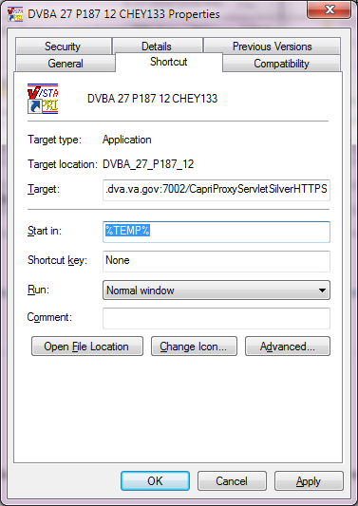

Figure 9. Example of Starting CAPRI from a TEMP Directory Location

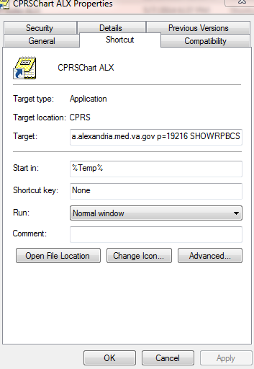

Figure 10. Example of CAPRI accessed via CPRS

Benefits:

1. Each user is guaranteed by Windows to have a unique writable folder.
2. It is a known environment variable and also guaranteed to exist in any environment.
3. Due to VA GPO Policy, this folder gets cleared on logon / logoff, hence no disk space impact is caused.

### 4.10.4 CAPRI Graphical User Interface (GUI) Verification Procedure

During the launch process of CAPRI, a splash screen displays indicating the version of the GUI being utilized.

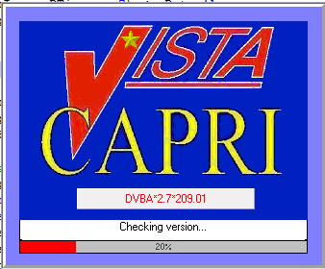

Figure 11. CAPRI Splash Screen

Users can also verify the version of the CAPRI GUI by selecting Help on the CAPRI menu, and then selecting About.

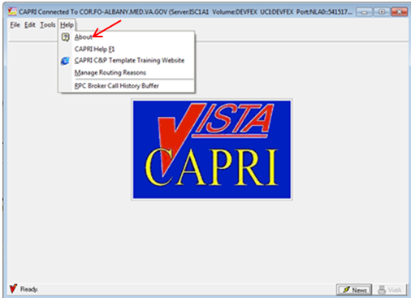

Figure 12. CAPRI Help Menu

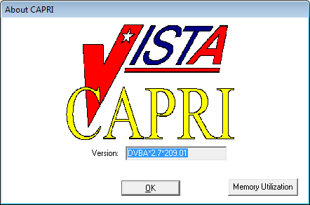

Figure 13. CAPRI About Splash Screen

## 4.11 Back-Out

Back-up procedures are handled by VistA which is totally independent of CAPRI. CAPRI requires VistA to work, but has no administration authority over VistA. Users contact VistA maintenance if connectivity goes down. The URL for VistA maintenance is: <http://vaww.va.gov/VISTAMAINTENANCE/index.asp>

Site specific for every VistA instance

CAPRI is a desktop tool that does not require a backup process. In case the need arises to restore CAPRI code, refer to the CAPRI Project area RTC for code management for executables and supporting files. https://clm.rational.oit.va.gov/ccm/web

## 4.12 Rollback Procedure

There will be no rollback capability to DVBA*2.7*193 following national release of DVBA*2.7*209 VistA structural changes will prevent rollback capability.

## 4.13 Rollback Considerations

N/A

## 4.14 Rollback Criteria

N/A

## 4.15 Rollback Risks

N/A

## 4.16 Authority for Rollback

N/A